File | Code | Comment
General | 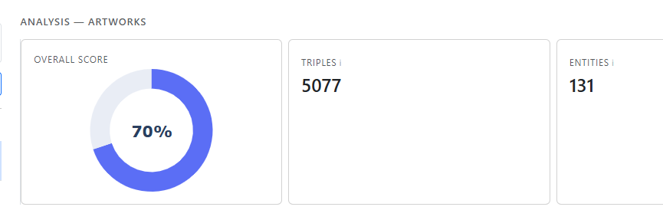  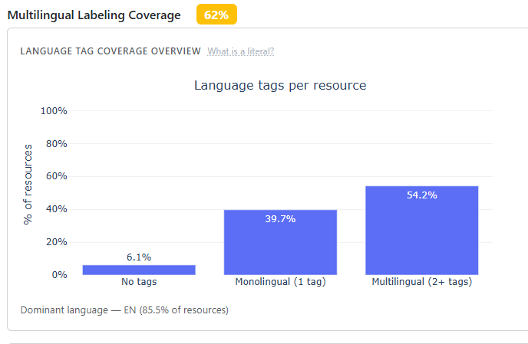  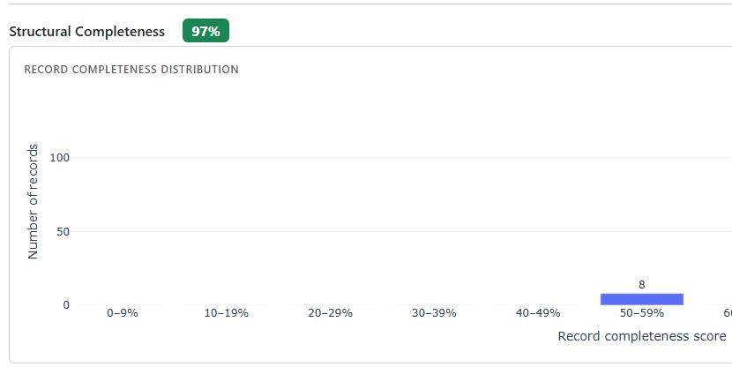 | I believe that in the different plots/tables we use different labels to name the same thing (entity, resource, record). If this were correct, and there is not a specific reason for calling them differently, I would choose one name and use it consistently everywhere.

File | Code | Comment
frontend/app.py | def sync_metric_selection(checklist_values):  from api_client import get_metrics, APIError  flat = []  for vals in (checklist_values or []):  flat.extend(vals or [])  try:  metrics = get_metrics()  metric_order = [m["metric_id"] for m in metrics]  flat.sort(key=lambda m: metric_order.index(m) if m in metric_order else 999)  except APIError:  pass # if API fails, return unsorted  return flat | I added some lines of code here to read again the metrics_config.json file so I can sort the selected metrics so later the results are sorted with the order on the sidebar, rather than with the order they were selected.
General |  | When I load this file, I can see 6 classes, when I evaluate it, if later I click in property coverage I see the 6 classes in the corresponding plots, the same with multilingual and foundational but I see only 4 in the structural completeness, the classes missing are license and organization.
frontend/callbacks/sources.py | def populate_metrics(_):  accordion = dbc.Accordion(  items,  start_collapsed=False,  always_open=True,  flush=True,  className="mb-1",  style={"fontSize": "0.875rem"},  ) | I have added this line, so the sidebars remain open if i dont close them , rather than self-close when open one

File | Code | Comment
frontend/layout/sidebar.py | def build_add_source_modal() -> dbc.Modal:  # RDF File fields  html.Div(  id="source-fields-rdf",  children=[  dbc.Label("File path", html_for="input-file-path"),  dcc.Upload(  id="upload-rdf-file",  children=html.Div([  "Drag and Drop or ",  html.A("Select File", style={"color": "#6c8ebf", "cursor": "pointer"}),  ]),  style={  "borderWidth": "1px",  "borderStyle": "dashed",  "borderColor": "#adb5bd",  "borderRadius": "6px",  "textAlign": "center",  "padding": "20px",  "cursor": "pointer",  "backgroundColor": "#f8f9fa",  "marginBottom": "8px",  },  ),  html.Small("or enter path manually", className="text-muted my-1 d-block"),  dbc.Input(  id="input-file-path",  placeholder="e.g. C:\\Users\\victo\\data\\file.ttl",  className="mb-2",  ),  html.Div(id="upload-filename-display", className="text-muted mb-2",  style={"fontSize": "0.8rem"}),  dbc.Label("Format", html_for="input-file-format"),  dbc.Label("Format", html_for="input-file-format"),  dbc.Select(  id="input-file-format",  options=[  {"label": "Turtle (.ttl)", "value": "turtle"},  {"label": "RDF/XML (.rdf)", "value": "xml"},  {"label": "N-Triples (.nt)", "value": "nt"},  {"label": "N3 (.n3)", "value": "n3"},  ],  value="turtle",  ),  ],  ), | I change it to be able to drag and drop files when loading data, at least for me it make it easier to test things from the interface.  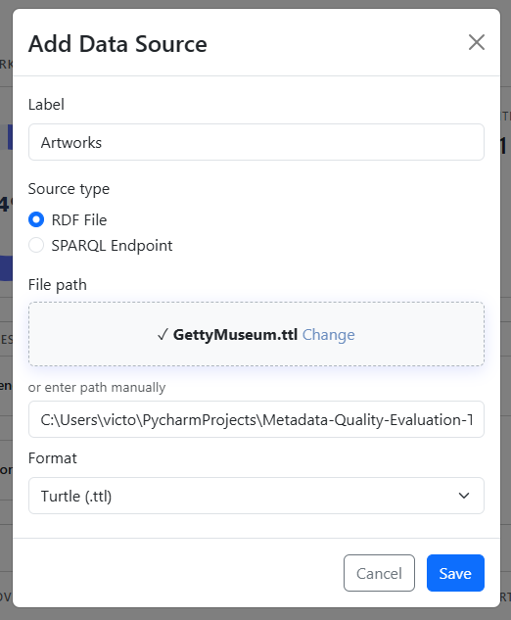
General | 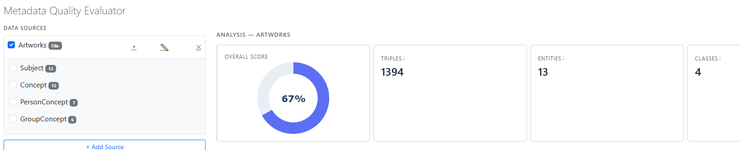  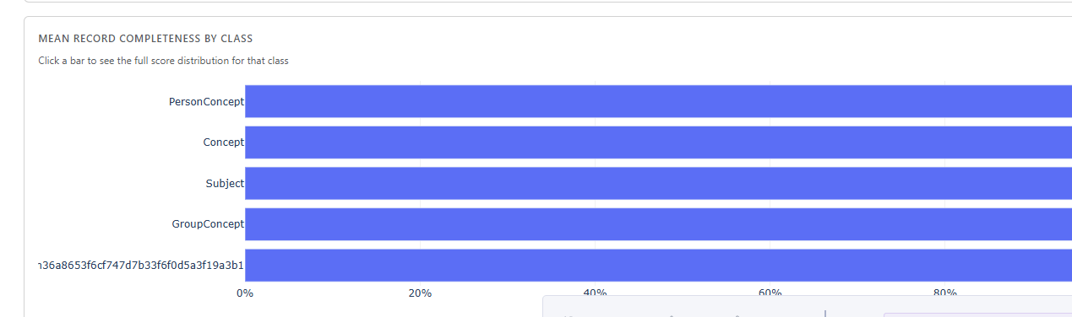 | I manage to get some data from Getty museum . The important thing is that when I run the analysis, I see 4 classes on top, but the graph “MEAN RECORD COMPLETENESS BY CLASS” shows a 5 one.

File | Code | Comment
General | 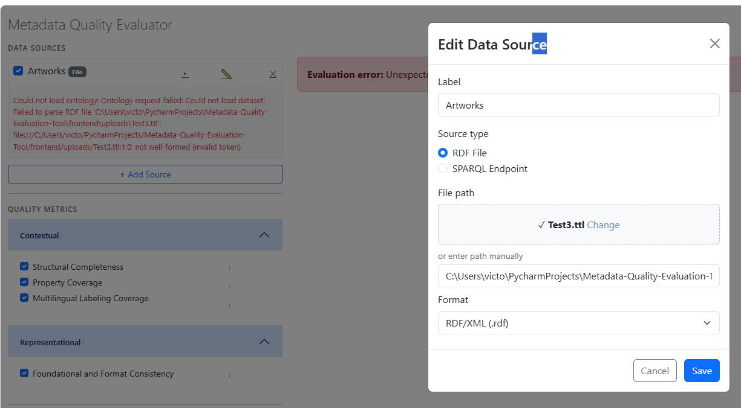  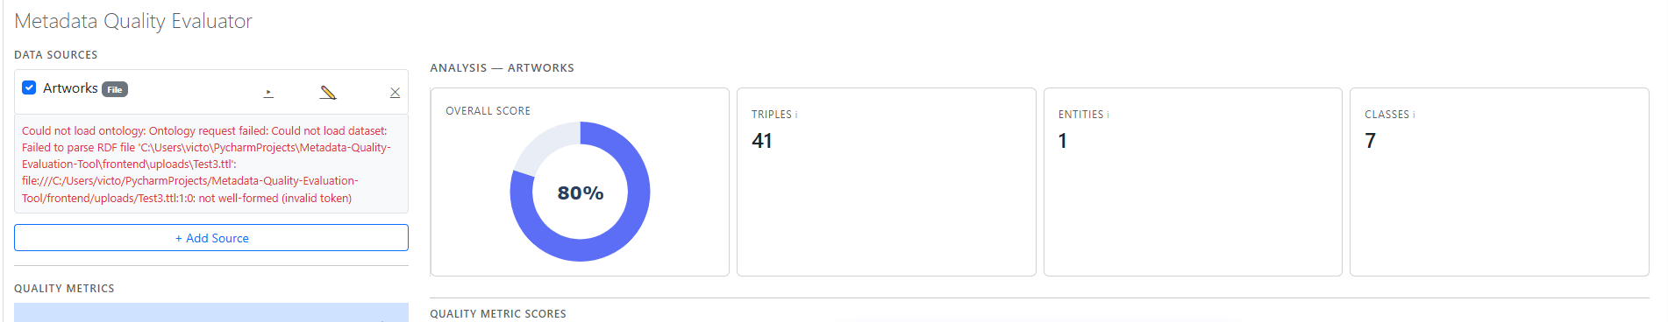 | When I add a RDF file, if I don’t choose the correct format, when I try to run the evaluation I will get an error as expected (first image).  If later I correct the Format of the file, the run evaluation will run as expected, but the error is still there, and actually I don’t see the classes of the data(second image)

General suggestion | 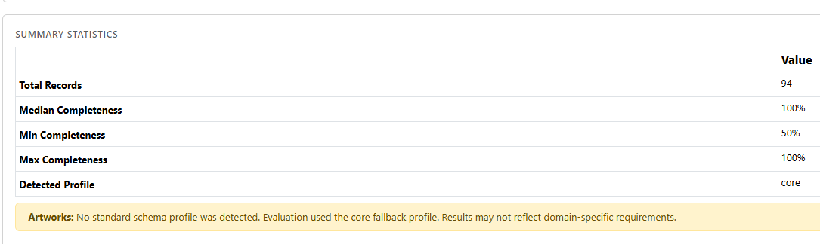 | Should we include somewhere the definition of the profile used to evaluate the Structural Completeness? After a while I found the folder with the profiles and the files with the shacl definitions, and I understood how it works, maybe we could add a button or similar somewhere, so when you clicked you see something like the image below  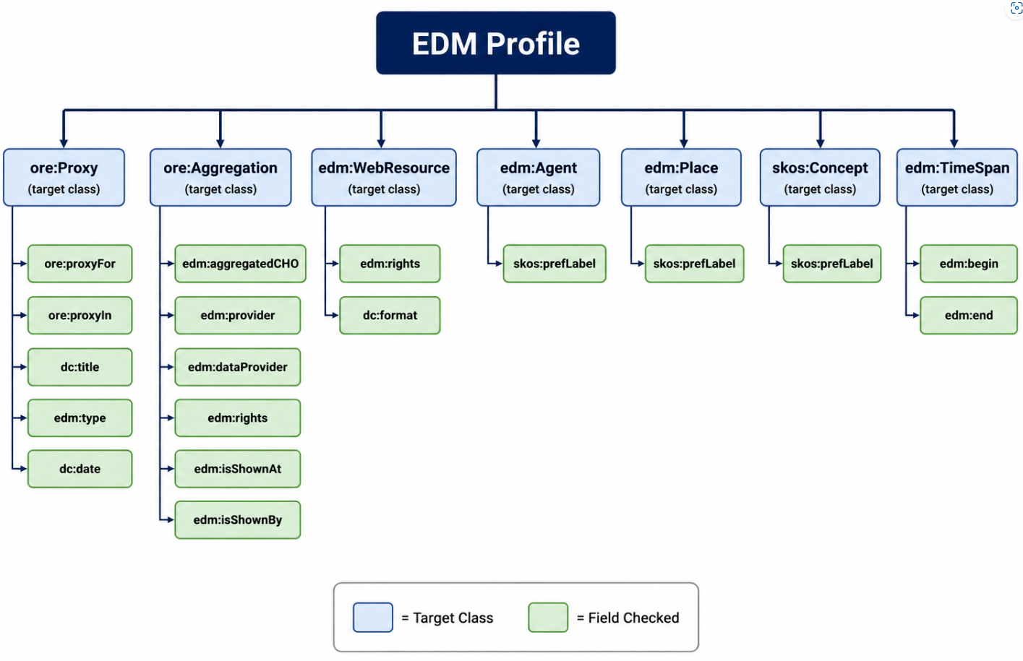

General | Classes/Ontology (sidebar)
 | 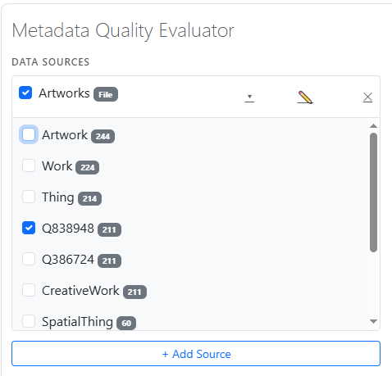 | I understand that the app find the classes of the loaded data and the number of entities per class. When two (or more) classes have the same entities, (in the image beside CreativeWork, Q838948 and Q386724) if later I select one of them, for example Q8389748, Run Analysis will show plots also for the equivalent CreativeWork and Q386724 classes.  After giving it some thought, I suggest a few possible changes (if they make sense).  - Detect equivalent classes (i.e., classes that share exactly the same entities). In theory, these classes would produce identical analysis results. I understand that there are some caveats: this equivalence depends only on the records currently loaded. For example, in another dataset, not all entities labelled as CreativeWork may also be labelled as Q8389748, so the two classes would no longer be equivalent. The bottom line is that I intend to merge the analysis results whenever classes are equivalent within the loaded dataset.  - I modified ontology_extractor.py so that it also returns an aliased_map. As a result, the frontend now looks like the example below. We now have only seven classes instead of the initial ten.  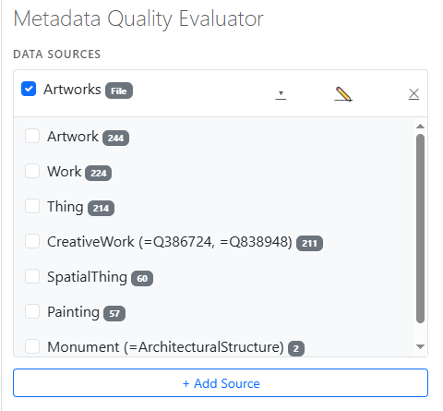  - I modified the code so that the ontology is fetched automatically when a source is added, rather than only after the user presses the corresponding button. I would automatically select all classes in the frontend when a source is added.

